My Personal Communication Dictionnary

What I Say or Do | What it means | What you should Say or Do
Thumb in mouth and finger above the eye | This is how I take in what is happening around me | - Talk to me  - Include me in activity  - Know that I am comfortable and content
Putting items non food items in mouth | - I want to interact with you  - I enjoy this  - I am exploring | - ‘Sign stop’  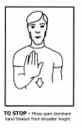  - It helps me when you tell me that I might get sick
Taps to fingers on chin | - I want something  - I will do this to tell you I want more of something when I am verbally prompted | - Use what I am asking for in a sentence and sign the words to me e.g. ‘yes you can have more drink  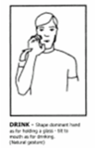
Sign “toilet”  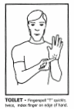 | - I need to use the toilet  - I am doing this because I have been asked to do something and I am signing toilet to show you I am busy | - In reference to the toilet sign:  - Acknowledge my request and point in the direction of the nearest toilet  - If I don’t go:  - Repeat the request or task and provide me with reassurance and mirror/gesture what you want me to do e.g. wiping the table, cleaning up after program etc…
Nod “yes” | - I am telling you ‘Yes’ | - Respond accordingly
Sign “no”  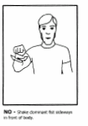 | - I am telling you ‘NO’ | - Respond accordingly
Rocking and being vocal accompanied by eye/mouth pose as above | - I need to do this in order to cope in my surroundings and need to be provided with another activity | - Note: this behaviour is frequent during unstructured program time e.g. lunch time  - Provide me with items from my ‘leisure pack’  - Spend time with me, include me in activities
Raising arm and keeping elbow still | - “Hello”
Walking up to you and making a gargling noise | - I am saying “hello”  - I want to spend time with you | - Wave hello  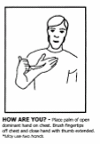  - Talk to me
I continue to sit there when you have asked me to move to next activity/program | - It takes me a while to stand up  - I like to be the last out of a room, so I know where everyone is | - Speak to me and sign once  - Then assist other people, I will follow when I am ready
I am tearful upon arrival to Milparinka in the morning | - I am upset  - I want to wear my moccasins | - Acknowledge that I am upset.  - It helps if you remind me that even though moccasins are more comfortable they are not safe to wear while at Milparinka.  - Have a joke with me about how it should be slipper/moccasin day everyday!

